CONTENT

Title pages
Executive summary 2
Business overview 3
Marketing plan 5
Operational plan 9
Organizational and management plan …………………… 17
Financial plan 20
Risk and mitigating factors… 21
Appendices… 24

EXECUTIVE SUMMARY

With the mission of providing foot wears that compete favorably in terms of quality with foreign products in the local markets at a price that represents value for money. Our Vision is to make the company a household name across the country and beyond. The company is registered with CAC as a sole proprietorship with YAKASON GLOBAL BEST VENTURE as business name.
The company’s strength lies in its unique ability, experience, deep knowledge, and acquired skills in running, efficiently, footwear production system to produce high quality and durable foot wears. We have researched the markets and identified our target customers such as schools, shoe selling corporate entities, and the middle class income earners.
Our expanding capital is =N 14,285,715.00 which is being source from the bank the sum of =N= 10,000,000.50 this capital will be invested in tools and equipment’s, expansion and raw materials to meet our target customers’ demand. Our projection for the next two years is to achieve sale revenue of =N=107,748,000.00 with gross profit of =N= 53,874,000. Net value of the business after loan repayment is =N=38,224,798.86.
Risks and competition such as foreign foot wears in the market, high cost of production owing to unsteady power supply, copy rights, etc, have been assessed and measures to mitigate these are in place. In favor and continued profitability of the business, measures such as value engineering production will be adopted to reduce unit cost and efficient time management to reduce fuel usage to mention a few.
This venture is highly viable and promises to contribute to the economic development of the country through employment of labor and tax revenue to the government.

  - BUSINESS OVERVIEW

  - Yakason Global Best Venture is into production and supply of trendy and high quality shoes for industrial and personal use at prices that represent value for the Nigerian populace.

Vision and mission statement

. The vision

To make Yakason footwear a household name Pan Nigeria and beyond.

Our mission

To provide foot wears that competes favorably with foreign products to the local market at a price that represents value for money.

The objective

Our key objective is to run production capacity to 100 - 150 pairs daily output, within the next three years with 20workers from the present 20 pairs per day with 8 workers

Value proposition

The company’s value proposition is to provide quality foot wears that meet end users need at a price that represent value through the combination of knowledge; experience marketing skills and efficient production systems.

The strategy

The company is leveraging on deep local insight and understanding of the market; technical ability, diversity in leather footwear work technology and optimally utilizing raw materials to reduce waste.

Current status of the business

The business is still evolving and carries out business as a formal entity under the business name Yakason Global Venture.
Currently production is run by eight workers and contract staff are brought in to complete jobs that overwhelm our staff strength to meet customers demand.

The industry and its potential challenges

The major players in the shoe industry in Nigeria are FAMAD (BATA); LENARDS and HAZAN. These companies are situated in Lagos with sales outlet spread across the country.
Other minor jobbers include Diamond Shoe; Sir Shoe; Tope Shoe; Femi Shoe etc.

The industry developed fast during the era of the foreigners between the 1960s to early 90s. Since then the industry has witnessed drastic decline in quality production of foot wears in the country. This led to importation of the so called Italian, China and Dubai shoes to meet public demands.
Currently the only company functioning at full capacity is HAZAN with daily output at 1000 pairs for synthetic products only. FAMAD is producing for scholars only due its peculiar challenges and LENARDS outsources production.
There is a huge market in Nigeria for foot wears but same has been dominated by imported shoes from aforementioned countries. Other problems faced in the industry include:
- Cost of fuel/diesel to run generator as alternative power supply:--this will be tackled and managed through efficient time sharing for low cost of production
- Export of high quality grades leather by local ternaries: ---We shall approach these entities with our specifications and buy materials from them.
- Dearth of skilled manpower in shoe technology:--There will be in house training and transfer of best practice in the business.
- Lack of state-of-the-art facilities and tools: - affiliation with foreign partners

- Mentality of Nigerians on imported shoes against locally manufactured shoes;- extensive awareness, producing to high quality and direct sales adverts.

Yakason has deep understanding of the shoe market by virtue of his sixteen years of active involvement in the shoe making industry and is poised to maximize the potentials of the market to remain competitive. Currently the Company is partnering with Shoe Distribution Company (i.e. Lennards) in meeting demands of the market and will combine local insight with global best practice to produce quality foot wears that represent value to all categories of end users.

Contribution to national economy

The company will contribute to national economic the following:

    - It would create employment opportunity to the society ,

    - Reduce crime rate since idle youths would be employed;
    - Improves economic development, improve in goods and services, also bring economic growth and serve as source of revenue for government.
    - It would create revenues for the government through taxes and levies

Marketing Plan

  - Products and service offerings

We produce and supply high quality and appealingly designed foot wears tailored to meet customers’ specifications. Our foot wears are durable and affordable and compete with foreign foot wears which are not affordable to the low and medium income earners in the Nigerian market.

Product/service packaging and delivery

Our products will have emblem of Yakason as a brand and packaged under the following categories:
Product 1. (Corporate shoes) Ten pairs per Carton Product 2. (back to school) Twelve pairs per Carton Product 3. (military boot) fifty pears per bag Product 4. (safty boot) ) fifty pears per bag

Delivery terms

The following terms shall apply for corporate demands/orders:

    - Samples shall be presented before order is produced to quantity.
    - Delivery timeline shall be agreed.
    - Following acceptance of samples and pricing, advanced payment of 60% of total cost shall be made by the client.
    - Balance of payment (40%) shall be remitted by the client on final delivery of order.
    - Pricing is negotiable based on volume.
    - Once production has commenced order may not be cancelled.
    - Other terms as required by the client are welcome.

The Opportunity

The country’s over dependence on importation of quality foot wears has reduced following the ban placed by the Nigerian government to encourage local manufacturers in order to burst her economic. Yakason is therefore poised to fill the demand for quality foot wears at prices that are affordable and that represent value to end users.

Pricing Strategy

Standard costing method shall be adopted in setting price for our products to cover the costs of production and delivery as well as profit mark up to cover loan repayment and going concern of the business. Refer to proposed price list and sales forecast in the appendix for details.

Target market

Target customers are schools, corporate dealing in shoe distribution, and general buyers visiting Yakason outlets. Market size is estimated at about ten million end users across schools and corporate in the Nigeria market alone. Markets outside Nigeria include ghana, cameroon, mali, beni, cotdevoer, botswana, south africa Kenya, Egypt e t c are estimated at two hundred thausand end users.
The company will leverage on its existing relationship with foot wear companies i.e Lennards to boost sales and also reach out t customers through the following channels to ensure continuous sales:
Proposals and visits to target customers; Flyers and complimentary cards; Adverts in church weekly bulletin; Website ;
Social media

Sponsoring of school PTA meetings;

The categories of footwear designs that are available for sales are: Adult shoes (both casual and corporate);
Military and paramilitary boots;

Students back to school and cover shoes.

Our targets population is the male adults and pupils.

Distribution strategy

We shall engage online marketing company, wholesale, retail and direct sales in making our products available to end users. Corporate delivery will be on wholesale price due to high volume involved whereas other forms of sales mentioned will be at standard price. At the start, Yakason will carry out bulk delivery through Truck hire until the business is able to procure bus for the next five years of profitability.

Promotional strategy

We are making our products known to targeted customers through flyers, complimentary business cards, face book, church bulletin adverts, face encounters, referrals, etc.

Sale method
Credit will be considered after long relationship with wholesale and retail buyers. Discount will also be granted base on volume purchase.

Competition

Based on market survey our competitors are mainly the foreign shoe importers operating at Ikeja and Lagos Island. Others are Hassan shoes and Famads.

Competitive analysis

Factors | Yakason | Foreign shoe importers | Hassan Shoes | Famad | Importance to customers
Product | Scholar Palm Corporate  Corporate2 | Scholar Palm Corporate Corporate2 | Scholar Palm Corporate Corporate2 | Scholar Palm Corporate  Corporate2 | Comfort ability
Price | N3,000 N2,900 N10,000  N14,500 | N5,800 N20,300 N45,000  N55,500 | N3,500 N2,300 N3,000  N5,500 | N5,000 N4,300 N15,000  N17,500 | Affordable
Quality | Leather  (durable) | Leather  (durable | Synthetic  not durable | Leather  (durable | preferable
Experience | 10 years | 50 years | 13 years | 40 years | preferable
Reliability | Reliable | reliable | Not  reliable | reliable | preferable

  - Production Plan/Operational plan

Description of the location/factory

We have identified a strategic location at NO: 99 Abeokuta express way along a commercial avenue of Isaac John Street with links to Maryland and Ikeja environs. The space is a mini hall size that can contain all the equipment’s

Raw materials/consumables needed/Supplies

Material | Description | Key Supplier/Source | Comments
Leather | In square feet | UC & Son | Available
Rubber sole | In pairs | Emeka investment | Available
Insole | In sheet | ZICO Ltd | Available
Gum | In litres | ZICO Ltd | Available
Buckles | Packaged in 500 pairs | Izu Ventures | Available
Toe puff | In sheet | Izu Ventures | Available
Back stiff | In pairs | ZICO Investment | Available
Linning | In square  feet | UC & Son | Available
Leather  sole | In pairs | Izu Ventures | Available
Nora/sole | In sheet | Hit Man LTD | Available
Shanks | In pairs | Emeka  investment | Available
Leather insole | In square feet | Izu Ventures | Available
Polyurytine | In litres | Emeka  investment | Available

Other consumables include MEK, nails, Niddles, fuel, elastics, engine oil etc.

Product 1: SAFETY BOOT

S/N | DIRECT MATERIAL | QUANTITY | COST PER MATERIALS
1 | Upper | 4sqft | N1,200
2 | Lining | 2.5sqft | N300
3 | Sole | 1 pair | N2,410
4 | lace | 1 pair | N100
5 | EYELET | 12 PAIRS | N16O
6 | Foam | Quarter yard | N80
7 | thread |  | N50
8 | Adhesive |  | N100
9 | P u |  | N100
10 | Shank | 1 pair | N50
11 | Toe CAP |  | N300
12 | Back stiff | 1 pair | N100
13 | Ornament | 1 pair | N50
 |  |  | N5,000

PRODUCT 2:BACK TO SCHOO SHOES
S/N | DIRECT MATERIAL | QUANTITY | COST PER MATERIALS
1 | UPPER | 2SQFT | N1,260
2 | LINING | 2SQFT | N200
3 | SOLE | 1 PAIR | N350
4 | P U | PAIR | N200
5 | ADHESIVE | PAIR | N100

6 | TOE/BACK  STIFF | PAIR | 70
7 | INSOLE | PAIR | N40
8 | FOAM | PAIR | N20
9 | SOCKS | PAIR | N40
10 | BUCKLE | 1 PAIR | N100
11 | THREAD | PAIR | N20
12 | REVETE | PAIR | N10
 |  |  | N2,500

PRODUCT 3:MILITARY BOOT

S/N | DIRECT MATERIAL | QUANTITY | COST PER MATERIALS
1 | UPPER | 4SQFT | N1600
2 | LINING | 2SQFT | N200
3 | LACE | 1 PAIR | N100
4 | PACKAGING | 1 PAIR | N500
5 | SOLE | 1 PAIR | N2000
6 | INSOLE/SHANK | 1 PAIR | N200
7 | P U | 1 PAIR | N400
8 | ADHESIVE | 1 PAIR | N200
9 | TOE/BACK  STIFF | 1 PAIR | N300
10 | REVET | 1 PAIR | N150
 |  |  | N5,650

PRODUCT 4: CORPORATE 2 SHOES

S/N | DIRECT MATERIAL | QUANTITY | COST PER MATERIALS
1 | UPPER | 3SQFT | N1,000
2 | LINING | 2SQFT | N400
3 | SOLE | 1 PAIR | N300
4 | P U | 1 PAIR | N100
5 | ADHESIVE | 1 PAIR | N70
6 | TOE PUFF | 1 PAIR | N150
7 | INSOLE  /SHANK | 1 PAIR | N150
8 | SOCKS | 1 PAIR | N60
9 | THREAD | 1 PAIR | N70
10 | LACE | 1 PAIR | N100
11 | BACK STIFF | 1 PAIR | N50
12 | PACKAGING | 1 PAIR | N00
13 | ORNERMENT | 1 PAIR | N50
 |  |  | N2,700

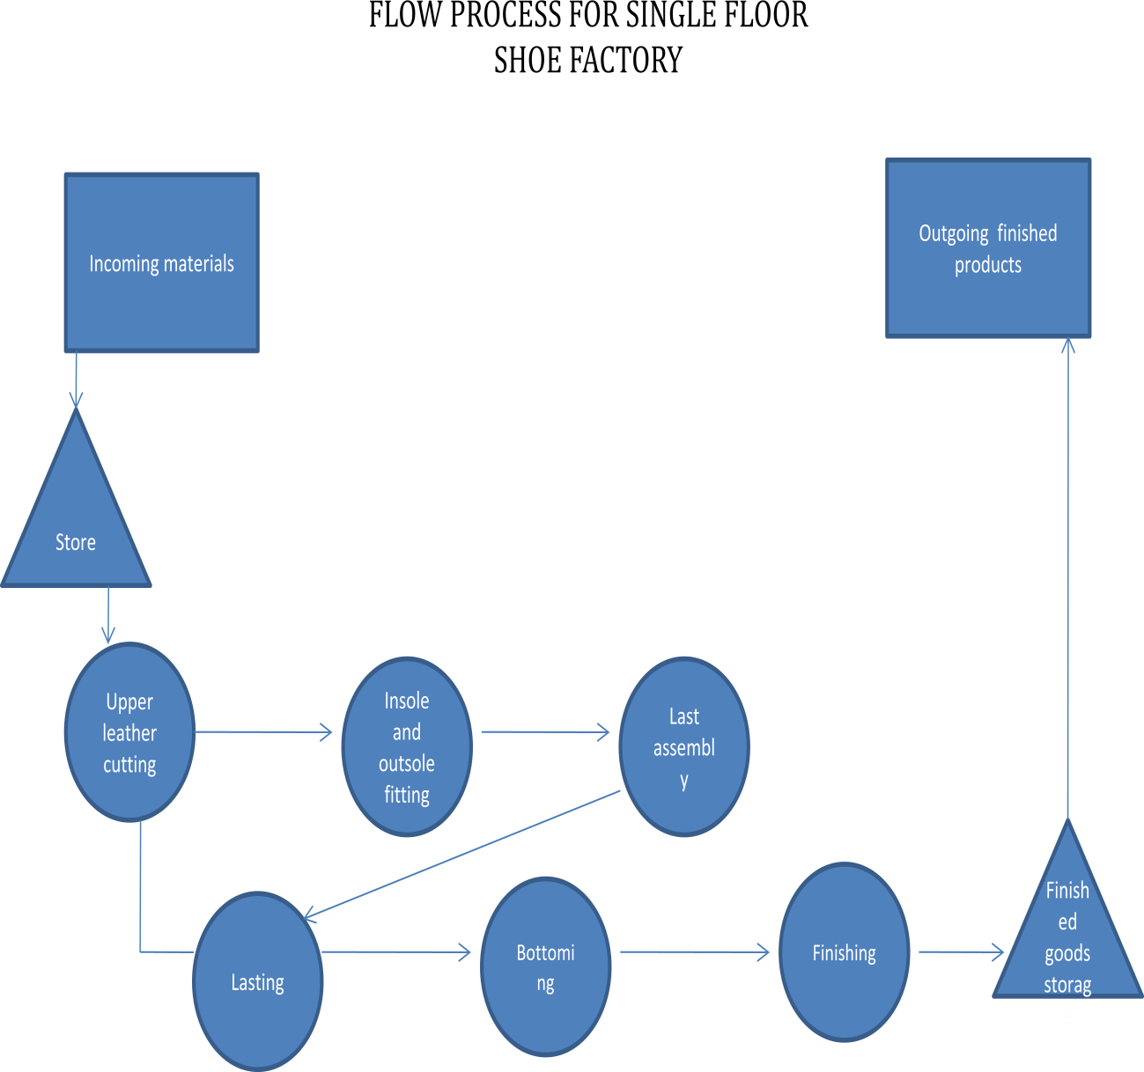

Labor

Essentially we are employing skilled and unskilled laborers for production. The unskilled with assist the skilled and learn with time. Overall, gloves and safety boots will be provided for workers. Working hours will start from 8 am to 5 pm Monday to Saturday (9am to 3pm).

Production capacity

Our production plan according to staff strength of Eight is 500 pairs per month. This however is subject to demand as full capacity of the production floor is 700 pairs per month.

Legal requirement

The business has been registered with the Corporate Affairs Commission (CAC) and Standard Organization of Nigeria (SON).

3. 8 Milestones

Activity | Funding | Budget (=N=) | Yea r 1 | Yea r 2 | Year 3 | Yea r 4 | Yea r 5
Opening of business | Personal  fund | 30,000 | X
Rent | Personal  fund | 1,000,00  0 | X
Acquisition of equipment | Loan | 8 million | X
Commence production capacity of 700 pairs/month |  | 1.2  million | X
Producing at 1500  pairs/month |  |  |  | X
Purchase of delivery van | Profit reserve | 4.2  million |  |  | X
Opening of sales outlet outside Lagos | Profit reserve | 500,000 |  |  |  | X
Workforce expansion to  95 employees | Operating  expenses | 150  million |  |  |  |  | X
Acquisition of land | Profit  reserves | 10 million |  |  |  |  | X

3.6 Stock control process

Yakason will keep the following inventory such as -: Raw materials, work in progress (W I P), finish goods, tools inventory and maintenance repair and operating store.

Organizational and management plan

  - Our company is sole proprietorship register with C.A.C, Operating with eight (8) staff.
We are in a process of upgrading to limited liability.

The entrepreneur’s profile Name LIVINUS JAMES
99 Abeokuta Express, By Iyana Dopemu Lagos
Tel: 08080880439, Email: yakason2007@yahoo.com

OBJECTIVE: To provide solution and innovation in the Nigeria footwear Industry
PERONAL DATA

Date of birth: October 1, 1975

State of origin: Kaduna

Sex: Male

Marital status: Married

INSTITUTION ATTENDED AND QUALIFICTION

Federal college of chemical and leather technology 1996 - 1998
Certificate in foot wear manufacturer

Data flex Computer College 2007 - 2008
Diploma in computer science

Government secondary school 1988 –
1994
Senior school certificate examination

TRAINING ATTENDED

African Growth Opportunity Act and Bank of Industry (AGOA/BOI)
Courses on Export

2014

Small and Medium Enterprise Development Agency of Nigeria
Courses on Marketing/Networking 2013

Lagos business school
Courses on Entrepreneurship and Business Plan Development 2011

African leadership forum ikeja Lagos
Classes on leadership/management 2011

Footwear Accessory Manufacture and Distribution Lagos (FAMAD)
Training on shoe making and grading

2009
Training on shoe costing and waste management 2008
Training on product branding ikeja Lagos

Total Nigeria Plc. Kaduna
Classes on Quality Assurance (ISO)

2003
Training on fire prevention

2002
Training on small and medium scale enterprise NDE Kaduna 2000

AWARDS
Best governor African leadership 2011
Youth enterprise with innovation in Nigeria Federal ministry of finance 2012
WORKING EXPERIENCE

Yakason shoe, Lagos 2011- date
- Chief executive officer Lagos

Footwear Accessory Manufacture and Distribution Lagos
(FAMAD) Formally BATA 2005 -2008
- Shoe Designer
- Costing clerk
- Team Lead, Cutting Department

Lennard Shoes Nigeria Plc. 2009 -2010
- Production Manager

Total Nigeria plc. 2000 - 2004
- Security assistant

HOBBIES

Reading and travelling

  - KEY MANAGMENT TEAM

Name | Educational backgrond | Position helt | Relevan experience
James Livinus | Certificate in foot wear manufacturing, | C E O | Footwear design and production; Production Manager Lenards;  Designer FAMAD
Ashimuyu Akinbode | BSC Business admin | Production Manager | Footwear design and production; Production Manager Lenards;  Designer FAMAD
Vincent Udoka | O N D | Merchandise Manager | Footwear Merchandise clerkFAMAD
Netok Gomwalk | BSC Accounting | Accountant

  - STAFF SALARY SCHEDULE
C E O
ACCOUNTAN
PRODUCTION
MERCHANDISE/S
MARKETING
CUTTING/CLOSSING
FINISHING
MARKETERS
16
WORKERS
S  / N |  | DESINGNATI ON | TASK | REQUIRED SKILL AND EXPERIENCE |  | MONTH LY SALARY |  | ANNUAL SALARY
1 | C E O |  | DIRECTING |  | ENTREPRENUERER SKILL/FOOT WEAR TECHNOLOGY |  | 50,000 |  | 600,000
2 | MERCHANDISE MANAGER |  | MONITORING/RECRDING  SYSTEM |  | O N D |  | 40,000 |  | 480,000
3 | MANAGER |  | DESIGN/PLANING |  | FOOTWEAR MANUFACTURE |  | 40,000 |  | 480000
4 | ACCOUNTING CLERK |  | KEEPING FINANCIAL RECORD |  | S S C E |  | 20,000 |  | 240,000
5 | SUPPERVISOR |  | LASTING/FINISHING |  | FOOT WEAR BASIC |  | 20000 |  | 240000
6 | SUPPERVISOR |  | CLOSSING |  | FOOT WEAR BASIC SKILL |  | 2000O |  | 240000
7 | SUPERVISOR |  | CUTTING/QUALITY CHEECKER |  | FOOT WEAR BASIC SKII |  | 20000 |  | 240000
8 | HELPER |  | UNSKILL |  | S S C E |  | 15,000 |  | 180,000
 |  |  |  |  |  |  | N225,000 |  | N2,480,000

5.0 Financial plan SALES ASSUMPTIONS
- Corporate Shoe peak period: In April, this product could go up due to Easter celebration when people will have different occasions to attend.
- From September to December the products move faster too because of Christmas, Salah weddings, burial, and naming ceremonies.
- SCHOOL SHOE: In September /October alone this period can generate such level of income that will make the profit of the whole year’s activities.
- Next is JANUARY and APRIL Sales when students who could not buy or use sandals in the first term of the school year would need it for next term especially those old shoe are worn out.
- Military Boot: This product is an all-year -round product which attracts effective demand if made from quality material
- SAFETY BOOT A product targeted at the Idustries it sale all rount the year

OFF PERIOD are sales around the periods February, March, May, June, July and August. Other clients or prospective users who may not be able to buy in the PEAK PERIOD are expected patronize the product.

Risk Analysis and Mitigating factor

Competitors importing china and Dubai shoes which are not durable
High cost of production due to prolonged power outage
Data loss due to system crash (IT)
Product adulteration and copy right mass production

Delivery quality shoe to the end user with awareness on durability
Efficient and economic use of generator in the production floor through work scheduling
Back up plan for securing and storing of data (external hard disk)
Brand name and emblem will be stamp in the product

  - BUSINESS SWOT ANALYSIS SCHEDULE

FACTORS IMPLECATIONS

STRENGH  Experience, Skill in design and Production  Ability to utilize raw material with minimal waste  Deep knowledge of the business | Quality designs  Various appealing designs Product at lower cost
WEAKNESS  Financial constraints Low staff strength  Inadequate tools | Inability to produce to scale In ability to meet demand Loss of business opportunity
OPPORTUNITIES  Relationship with leading shoe traders  Schools with high seasonal demand Deep marketing skill to penetration | Supplies order from corporate Demand from school  High revenue
TREATS  Competitors, Importers  High cost of running on generator | Market share Cost of product

